Dina Moustafa

Chem 6004

Dr. Foley

April 19, 2019

**Mie First Questions**

**Question 1: How does the spectrum change as you increase the dielectric constant of the surrounding materials? Try n = 1.45 for glass and n = 1.76 for alumina.**

1. Water = 1.33 dielectric constant, peak = 383 nm, abs = 1.57

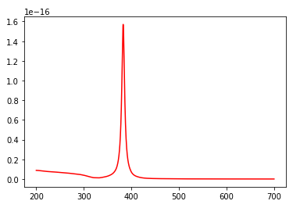

1. Glass = 1.45 dielectric constant, peak = 396 nm, abs = 1.66

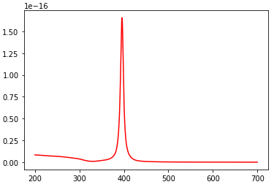

1. Alumina = 1.76 dielectric constant, peak = 4.33 nm, abs = 2.30

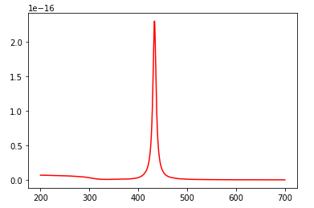

As the dielectric constant increases the spectrums experience bathochromic shifts. The wavelength increases from 383 nm (water) to 396 nm (glass) and 4.33 nm (alumina). The absorbance of the spectrums also increases as the dielectric constant increases from 1.57 (water) to 1.66 (glass) and 2.30 (alumina).

**Question 2: How does the spectrum change as you decrease the dielectric constant of the surrounding materials? Try n = 1.0 for air.**

1. Water = 1.33 dielectric constant, peak = 383 nm, abs = 1.57



1. Air = 1.00 dielectric constant, peak = 354 nm, abs 0.636

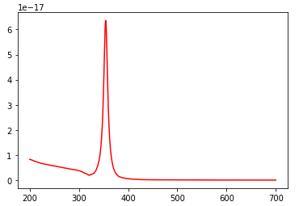

As the dielectric constant decreases, the spectrum experiences a hypsochromic shift. The wavelength decreases from 383 nm (water) to 354 nm (air). The absorbance of the material also decreases from 1.57 (water) to 0.636 (air).

**Question 3: How does the spectrum change if you use Au instead of Ag?**

1. Ag, Water = 1.33 dielectric constant, peak = 383 nm, abs = 1.57



1. Au, Water = 1.33 dielectric constant peak = 521 nm, abs = 0.082

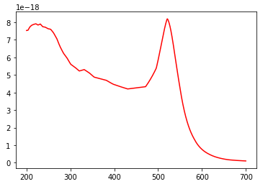

1. Au, Air = 1.00 dielectric constant, peak = 208 nm, abs = 0.068

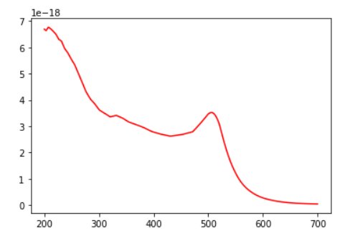

Using Au instead of Ag causes the spectrum to experience a bathochromic shift and the absorbance of the spectrum decreases. The Au spectrum has two peaks around 210 nm and 521 nm. The wavelength max when the surrounding material is water is 512 nm. When the surrounding material is air, the wavelength max is 208 nm.

**Question 4: Plot the real and imaginary parts of the dielectric function of Au and Ag as a function of wavelength; what do you notice about the values in the vicinity of the plasmon resonance (i.e. at wavelengths where the strong absorption peak is observed)?**

1. Ag, water = 1.33 dielectric constant

Blue = real

Red = imaginary

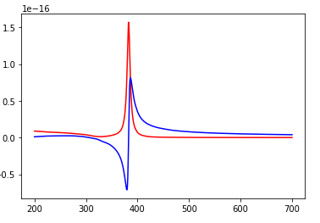

The real part of Ag experiences a negative absorbance at 380 nm and obtains a wavelength max at 400 nm. Whereas the imaginary part only experiences a wavelength max at 383 nm at an absorbance of 1.57. These wavelength values seem to be within the same vicinity.

1. Au, water = 1.33 dielectric constant

Blue = real

Red = imaginary

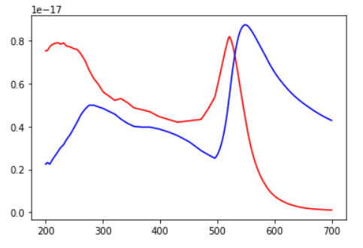

The real part of Au has two peaks at approx. 300 nm and 550 nm. The imaginary part of Au has two peaks at approx. 208 nm and 512nm. The real part bathochromic shifts from the imaginary part.